|  |  |
| --- | --- |
| **Sue Darby** | [sue@sue-a-darby.com](http:///h)[www.sue-a-darby.com](http:///h) |
| Cell 907-707-5654 |

Sound Web Solutions [(907) 745-2015, Palmer / Wasilla](http://soundwebsolutions.net/contact-us/callto:9077452015)

642 S. Alaska St, Ste 200 [1-866-418-0937, Toll Free](http://soundwebsolutions.net/contact-us/callto:8664180937)  
Palmer, AK 99645 [info@soundwebsolutions.net](mailto:info@soundwebsolutions.net)

Heidi Weiland and Karen Weiland,

Let me first introduce myself and why I am applying for your **Web Designer and WordPress Enthusiast** with *Sound Web Solutions*. I am a geek who loves code and websites. For a while I resisted the call to code but no more, as I am now seeking the the answer to life, the universe and everything. I believe *Sound Web Solutions* is the answer.

Recently I have been working with iA3, a local start-up tech company as their webmistress. I have taken the prototype website from HTML using Bootstrap to a fully launched WordPress backed website. I have also launched Twitter and Facebook accounts for the company site and continue to work on creating content for marketing.

As a Senior Services Technician for the State of Alaska, I am the Provider Certification and Compliance Unit’s administrative support. I have achieved many things during my time, including procedure writing, database changes via requirements documentation, report building, advanced spreadsheets and macros with extensive VB.net programming. I'm also the subject matter expert and administrator for the several SharePoint sites for the Division troubleshooting and developing tools used by staff.

I have been hooked on code since the 90's, but sought out other interests, all the while gravitating back to the websites. I started using old versions of HTML, well before CSS was thought of and updated my skills as needed. Eventually I bumped into WordPress, Drupal and Joomla but ultimately came to love WordPress best.

My websites have migrated between hosts and changed more times than I can count. I have installed WordPress, Joomla, and Drupal via a cPanel system and as manual installs using FTP. I have setup numerous SQL databases and dug fearlessly into the code to fix things that have gone wrong, researching to learn whatever I needed, or wanted to know.

I continue to expand my knowledge base with multiple online learning resources and own multiple books on a variety of topics from general HTML to more advanced mobile web design, WordPress Theme development and even game and mobile app development.

Whilst seeking the answer to life, the universe and everything I have realized that the answer is 42 or a bigger challenge professionally. No matter what I look forward to speaking with you and your team further to determine where my skills could fit in. You can reach me at 907-707-5654 or via email at [sue@sue-a-darby.com](mailto:sue@sue-a-darby.com).

Sincerely,

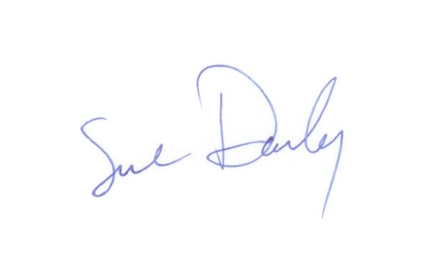

Sue Darby